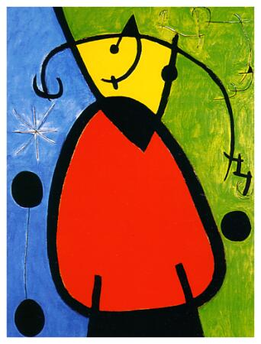
Abstract Art Primer

The essential concept of abstract painting is that the content can come from inside the artist rather than the outside, material world. It is rooted in “Impressionism” – art that emphasizes color, form, and shape instead of intricate details. Its influences range from calligraphy and other Eastern concepts to landscapes to music to stained glass to symbolism to spirituality.
- J.M.W. Turner (1775-1851, England) – Known as “the painter of light”; impressionism.
- Claude Monet (1840-1926, France) – Founder of French Impressionism, his Water Lillies opened the door to abstract painting.
- Pablo Picasso (1881-1973, Spain) – His Cubism was an important development in abstraction.
- Piet Mondrian (1872-1944, The Netherlands, London, NYC) – His minimal geometry concepts are still popular.
- Wassily Kandinsky (1866-1944, Russia and Paris) – His ideas of inner spirituality and inner beauty included the interpretation of music onto canvas.
- Marc Chagall (1887-1944, Russia, Paris, America) – Perhaps the most famous Jewish artist in history. Did stained glass and paintings based on Jewish folklore, dreams, gypsies, dance, and other mystical influences. Gateway to surrealism.
- Salvador Dali (1904-1989, Spain) – The pinnacle of surrealism. Famous painting: “The Persistence of Memory.”
- Joan Miro (1893-1983, Spain) – Surreal Abstraction and Automatism. Optimistic tone.
- The Bauhaus – A German school of art and design open from 1919-1933. Many of the finest modern artists fled the Nazis and brought abstract concepts to America. Lecturers included Paul Klee, Josef Albers, Kandinsky, Mondrian, and many others.
- New York in the 1940’s and 1950’s
  - Mark Rothko and Hans Hoffman – Color-Field Theorists
  - Jackson Pollock – Abstract Expressionism or Action Painting – “I am nature.”
  - Lee Krasner – Pollock’s wife. “Neo-Cubist Abstraction Expressionism.”
  - Willem DeKooning – Women series, post-Alzheimer’s ribbons.
  - Helen Frankenthaler – Second-generation color-field theorist. Stains the canvas.
  - Joan Mitchell – Violent and expressive brushstrokes.
  - Mark Tobey – Calligraphic element. Painting as spiritual act: zen meditation.
  - Franz Kline – Reaction to industrialization and “The Expressionistic Gesture”
  - Frank Stella – Sculpture or Painting? Geometric boldness
  - Jasper Johns – Bridge between abstraction and pop art.
- After Abstract Expressionism, came Andy Warhol, Roy Lichtenstein, Keith Haring, Jean Michel Basquiet, and the Pop Art Movement.
- Present-day artists of note: Sean Scully, Romero Brito, Banksy, Melissa Meyer.
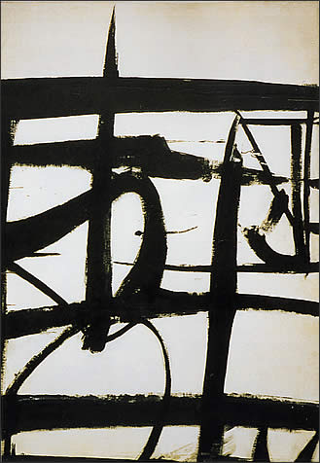
Abstract Paintings: Can you name the artist of each piece?
