Book Suggestions
by Mr. Weinstein’s AP Language students (June 2013)
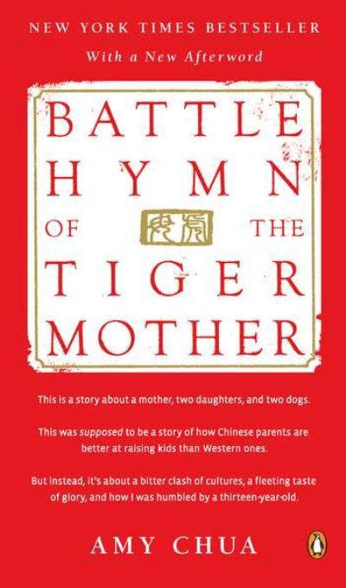

- A Christmas Carol by Charles Dickens
- An Introduction to Zen Buddhism by D.T. Suzuki
- And Then There Were None by Agatha Christie
- Battle Hymn of The Tiger Mom by Amy Chua
- Behind The Beautiful Forevers: Life, Death, and Hope In A Mumbai Undercity by Katherine Boo
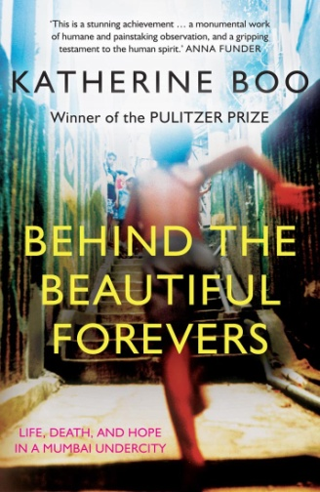
- Crash Into Me by Jill Sorenson
- Decoded by Jay Z
- Einstein by Walter Isaacson
- Elsewhere by Gabrielle Zevin
- Flowers for Algernon by Daniel Keyes
- Freakonomics by Steven D. Levitt and Stephen J. Dubner
- Game of Thrones series by George R.R. Martin
- Girl, Interrupted by Susanna Kaysen
- Gone Girl by Gillian Flynn
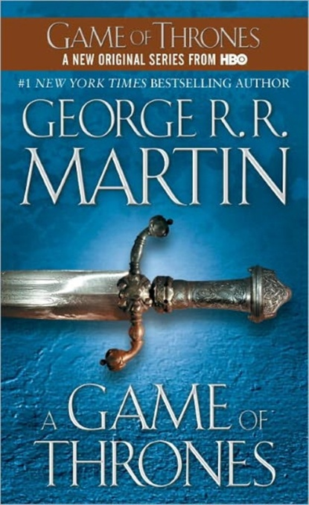
- I am Charlotte Simmons by Tom Wolfe
- If You Give a Pig a Pancake by Laura Joffe Numeroff
- Jane Eyre by Charlotte Bronte
- Little Bird of Heaven by Joyce Carol Oates
- Looking for Alaska by John Green
- Pride and Prejudice by Jane Austen
- Sherlock Holmes by Arthur Conan Doyle
- Shutter Island by Dennis Lehane
- Snowflower and The Secret Fan by Lisa See
- Steve Jobs by Walter Isaacson
- Suicide Notes by Michael Thomas Ford
- Sybil by Flora Rheta Schreiber
- The Adoration of Jenna Fox by Mary E. Peterson
- The Aeneid by Virgil
- The BFG by Roald Dahl
- The Curious Case of the Dog in The Nighttime by Mark Haddon
- The Davinci Code by Dan Brown
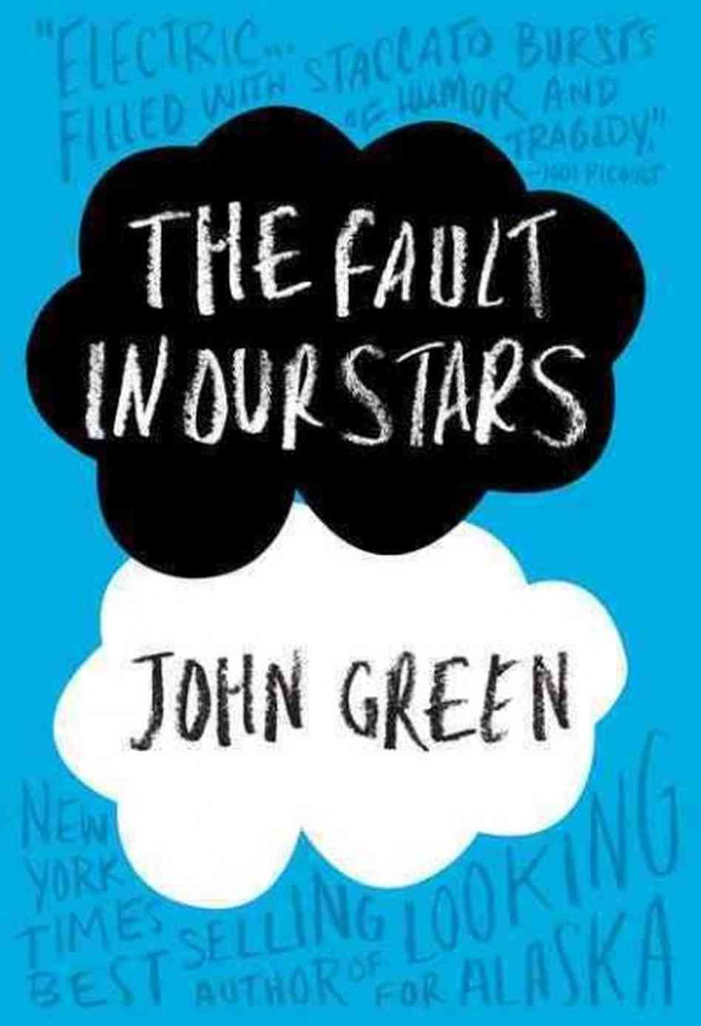
- The Fault In Our Stars by John Green
- The Firm by John Grisham
- The Five People You Meet In Heaven by Mitch Albom
- The Giver by Lois Lowery
- The Glass Castle by Jeanette Walls
- The Handmaid’s Tale by Margaret Atwood
- The Help by Kathryn Stockett
- The Hunger Games series by Suzanne Collins
- The Immortal Life of Henrietta Lacks by Rebecca Skloot
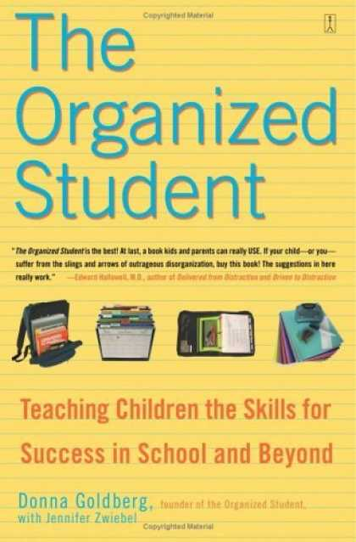
- The LA Candy series by Lauren Conrad
- The Organized Student by Donna Gilbert
- The Rules of Inheritance by Claire Bidwell SmithThe Timekeeper by Mitch Albom
- The Uglies by Scott Westerfeld
- Turnabout by Margaret Peterson Haddix
- Unwind by Neil Schusterman
- Who Moved My Cheese by Spencer Johnson

